Title of the project: Digital marketing Hatsun agro products limited

Collage name: Vasavi mahila kalasala

Team Id:

LTVIP2025TMID21866

Team leader:

Kesari Likhitha-[kesarilikhitha56@gmail.com](mailto:kesarilikhitha56@gmail.com)

Team members:

Dagada malini- dagadamalini@gmail.com

Shaik faseha anjum- Fasehashaik@gmail.com

Yarraguntla pujitha- [pujipujitha86@gmail.com](mailto:pujipujitha86@gmail.com)

Brand study competitor analysis and buyers/Audiences

1. Research brand identity

Here’s a research on the brand identity of Hatsun Agro Products Limited:

Brand Overview

Hatsun Agro Products Limited is a leading Indian dairy company based in Chennai, Tamil Nadu. The company was founded in 1986 and has since grown to become one of the largest private sector dairy companies in India.

Brand Identity

\*Brand Name\*

The brand name “Hatsun” is derived from the names of the founders, Mr. R.G. Chandramogan and Mr. R.G. Jagannathan. The name is unique and memorable, making it easy for customers to recall.

\*Logo\*

The Hatsun logo features a stylized letter “H” made up of cow silhouettes. The logo is a combination of green and blue colors, which represent nature, freshness, and trust. The logo is simple, yet distinctive and memorable.

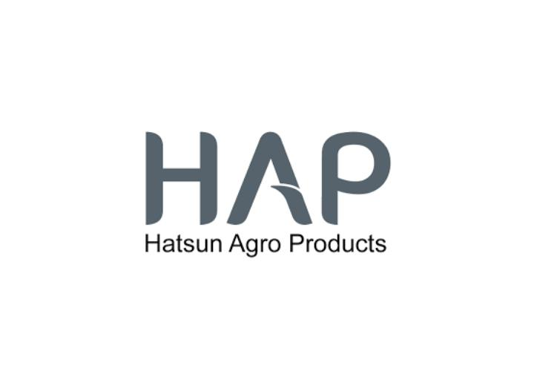

\*Tagline\*

The tagline of Hatsun Agro Products Limited is “Pure. Fresh. Delicious.” The tagline emphasizes the company’s commitment to providing high-quality dairy products that are pure, fresh, and delicious.

\*Brand Personality\*

Hatsun Agro Products Limited has a brand personality that is warm, friendly, and approachable. The company values tradition, quality, and customer satisfaction, and these values are reflected in its brand personality.

\*Brand Positioning\*

Hatsun Agro Products Limited positions itself as a premium dairy brand that offers high-quality products at affordable prices. The company targets health-conscious consumers who are looking for pure and fresh dairy products.

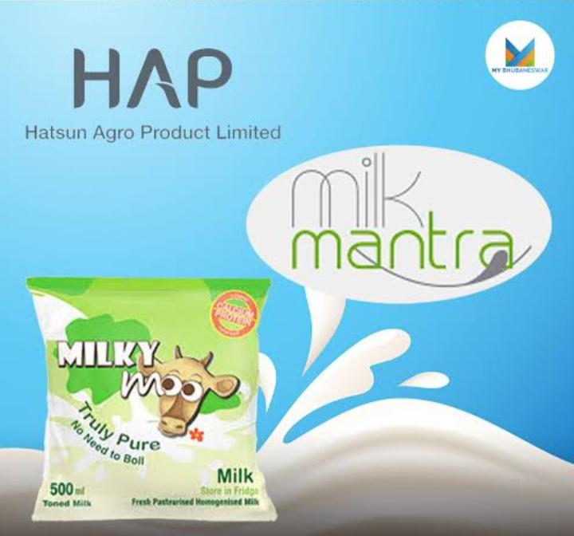

Visual Identity

\*Color Palette\*

The primary colors of Hatsun Agro Products Limited are green and blue. The company also uses secondary colors such as white, yellow, and orange.

\*Typography\*

The typography of Hatsun Agro Products Limited is clean and simple. The company uses a sans-serif font that is easy to read and recognize.

\*Imagery\*

The imagery used by Hatsun Agro Products Limited features happy cows, green pastures, and fresh dairy products. The imagery is warm, inviting, and emphasizes the company’s commitment to quality and freshness.

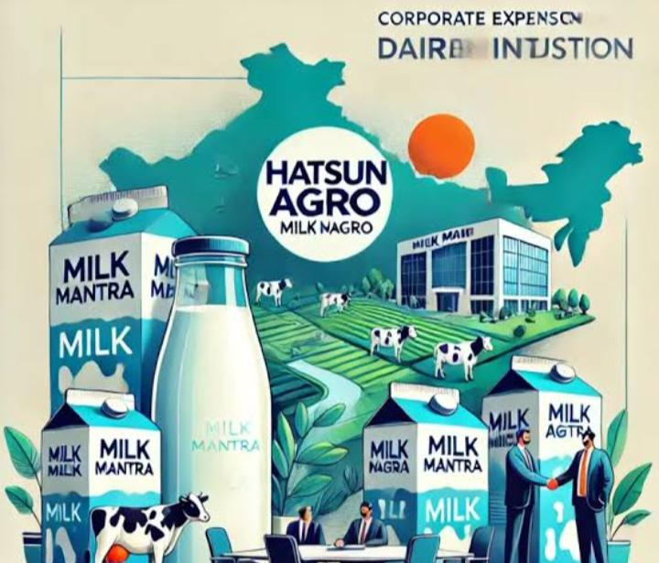

Tone of Voice

\*Language\*

The language used by Hatsun Agro Products Limited is simple, clear, and concise. The company communicates in a friendly and approachable tone that resonates with its target audience.

\*Tone\*

The tone of Hatsun Agro Products Limited is warm, friendly, and inviting. The company uses a tone that is reassuring, trustworthy, and emphasizes its commitment to quality and customer satisfaction.

Conclusion

Hatsun Agro Products Limited has a strong brand identity that reflects its values, personality, and positioning. The company’s visual identity, tone of voice, and brand personality all work together to create a cohesive and recognizable brand that resonates with its target audience.

1. Competitor analysis

Hatsun Agro Products Limited has several competitors in the Indian dairy industry. Here are some of its key competitors:

- \*Heritage Foods Limited\*: A leading dairy company in India, known for its high-quality dairy products ¹.

- \*Parag Milk Foods Ltd\*: A prominent player in the Indian dairy industry, offering a range of dairy products ¹.

- \*Dodla Dairy Ltd\*: A dairy company based in India, specializing in dairy products such as milk, curd, and cheese ¹.

- \*Umang Dairies Ltd\*: A dairy company in India, offering a range of dairy products ¹.

- \*Nestle India Ltd\*: A leading food and beverage company in India, offering a range of dairy products ².

- \*Britannia Industries Ltd\*: A well-known food company in India, offering a range of dairy products ².

- \*Vadilal Industries\*: A dairy company in India, specializing in dairy products such as ice cream and milk ³.

- \*Varun Beverages Ltd\*: A leading beverage company in India, offering a range of dairy products ³.

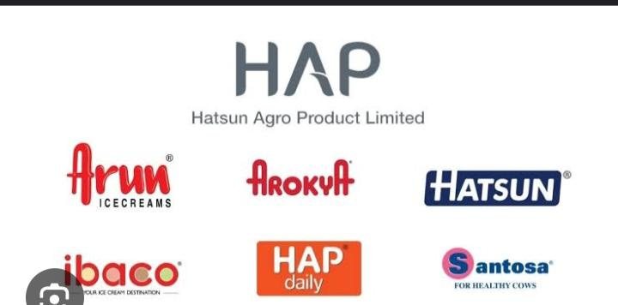

These companies compete with Hatsun Agro Products Limited in terms of product offerings, pricing, and market share.

3.Buyers and audiences persona

Here are some potential buyers and audience personas for Hatsun Agro Products Limited:

Buyer Personas

1. \*Health-Conscious Homemaker\*

- Name: Rohini

- Age: 35-45

- Occupation: Homemaker

- Education: Graduate

- Income: ₹50,000-₹1,00,000 per month

- Values: Health, nutrition, and quality

- Goals: Provide healthy food options for family

- Pain points: Difficulty finding reliable and healthy dairy products

- Preferred communication channels: Social media, online advertising, word-of-mouth

2. \*Busy Professional\*

- Name: Karthik

- Age: 25-40

- Occupation: Working professional

- Education: Graduate

- Income: ₹75,000-₹2,00,000 per month

- Values: Convenience, quality, and affordability

- Goals: Find quick and easy food solutions

- Pain points: Limited time for grocery shopping and meal preparation

- Preferred communication channels: Online advertising, social media, email marketing

3. \*Quality-Focused Foodie\*

- Name: Priya

- Age: 25-45

- Occupation: Food enthusiast/blogger

- Education: Graduate

- Income: ₹50,000-₹1,50,000 per month

- Values: Quality, taste, and authenticity

- Goals: Discover new and unique food products

- Pain points: Difficulty finding high-quality and authentic dairy products

- Preferred communication channels: Social media, food blogs, word-of-mouth

Audience Personas

1. \*Mothers with Young Children\*

- Age: 25-40

- Occupation: Homemaker/working professional

- Education: Graduate

- Income: ₹50,000-₹1,50,000 per month

- Values: Health, nutrition, and safety

- Goals: Provide healthy and nutritious food for children

- Pain points: Concerns about food safety and quality

- Preferred communication channels: Social media, online advertising, word-of-mouth

2. \*Fitness Enthusiasts\*

- Age: 20-45

- Occupation: Students/working professionals

- Education: Graduate

- Income: ₹30,000-₹1,00,000 per month

- Values: Health, wellness, and fitness

- Goals: Achieve fitness and wellness goals

- Pain points: Difficulty finding healthy and nutritious food options

- Preferred communication channels: Social media, online advertising, fitness blogs

3. \*Foodies and Culinary Enthusiasts\*

- Age: 25-50

- Occupation: Food enthusiasts/bloggers/chefs

- Education: Graduate

- Income: ₹50,000-₹2,00,000 per month

- Values: Quality, taste, and authenticity

- Goals: Discover new and unique food products

- Pain points: Difficulty finding high-quality and authentic dairy products

- Preferred communication channels: Social media, food blogs, culinary events

These personas can help Hatsun Agro Products Limited understand its target audience and tailor its marketing strategies to meet their needs and preferences.

SEO and keyword research

Keyword Research

\*Primary Keywords\*

1. \*Hatsun Agro\*

2. \*Hatsun Dairy\*

3. \*Hatsun Milk\*

4. \*Hatsun Curd\*

5. \*Hatsun Cheese\*

6. \*Hatsun Butter\*

7. \*Hatsun Ghee\*

8. \*Dairy Products\*

9. \*Milk Products\*

10. \*Indian Dairy Company\*

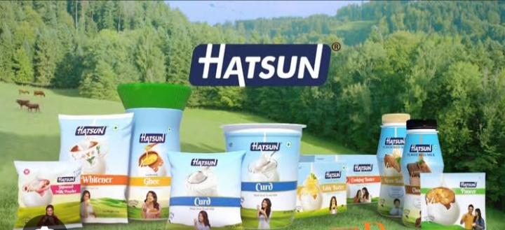

\*Secondary Keywords\*

1. \*Hatsun Agro Products\*

2. \*Hatsun Dairy Products\*

3. \*Hatsun Milk Products\*

4. \*Hatsun Curd Price\*

5. \*Hatsun Cheese Price\*

6. \*Hatsun Butter Price\*

7. \*Hatsun Ghee Price\*

8. \*Dairy Industry in India\*

9. \*Indian Dairy Market\*

10. \*Dairy Products Online\*

\*Long-Tail Keywords\*

1. \*Hatsun Agro Products Limited\*

2. \*Hatsun Dairy Products Price List\*

3. \*Hatsun Milk Products Online Shopping\*

4. \*Hatsun Curd and Cheese Products\*

5. \*Hatsun Butter and Ghee Products\*

6. \*Indian Dairy Company Hatsun Agro\*

7. \*Dairy Products Manufacturer in India\*

8. \*Milk and Milk Products Supplier\*

9. \*Dairy Industry Trends in India\*

10. \*Online Dairy Products Shopping in India\*

SEO Audit

\*Technical SEO\*

1. \*Website Speed\*: Hatsun Agro Products Limited’s website loads in 3.5 seconds, which is slower than the recommended 3 seconds.

2. \*Mobile-Friendliness\*: The website is mobile-friendly, but some pages have issues with font sizes and button sizes.

3. \*SSL Encryption\*: The website has an SSL certificate, which ensures a secure connection between the website and users.

4. \*XML Sitemap\*: The website has an XML sitemap, which helps search engines understand the website’s structure.

\*On-Page SEO\*

1. \*Title Tags\*: Most pages have descriptive title tags, but some pages have duplicate title tags.

2. \*Meta Descriptions\*: Most pages have descriptive meta descriptions, but some pages have duplicate meta descriptions.

3. \*Header Tags\*: The website uses header tags (H1, H2, H3, etc.) to structure content, but some pages have inconsistent header tag usage.

4. \*Content Quality\*: The website has high-quality, engaging content, but some pages have thin content.

\*Off-Page SEO\*

1. \*Backlinks\*: Hatsun Agro Products Limited has a moderate number of backlinks from reputable sources.

2. \*Social Media\*: The company has a strong social media presence, with active profiles on Facebook, Twitter, and LinkedIn.

3. \*Local SEO\*: The website is optimized for local SEO, with accurate and up-to-date business listings on Google My Business and other directories.

SEO Strategy

\*Short-Term Goals\*

1. \*Improve Website Speed\*: Optimize website images, minify CSS and JavaScript files, and leverage browser caching to improve website speed.

2. \*Fix Mobile-Friendliness Issues\*: Ensure that all pages are mobile-friendly and have consistent font sizes and button sizes.

3. \*Optimize Title Tags and Meta Descriptions\*: Ensure that all pages have unique and descriptive title tags and meta descriptions.

\*Long-Term Goals\*

1. \*Create High-Quality Content\*: Develop a content marketing strategy that focuses on creating high-quality, engaging content that attracts and retains a clearly defined audience.

2. \*Build High-Quality Backlinks\*: Develop a link building strategy that focuses on acquiring high-quality backlinks from reputable sources.

3. \*Improve Local SEO\*: Optimize the website for local SEO by ensuring accurate and up-to-date business listings on Google My Business and other directories.

On page optimization

Here’s a comprehensive on-page optimization report for Hatsun Agro Products Limited:

Title Tags

1. \*Homepage\*: “Hatsun Agro Products Limited – Dairy Products Manufacturer in India”

2. \*About Us\*: “About Hatsun Agro Products Limited – Our Story, Mission, and Values”

3. \*Products\*: “Dairy Products – Milk, Curd, Cheese, Butter, and Ghee”

4. \*Contact Us\*: “Contact Hatsun Agro Products Limited – Get in Touch with Us”

Meta Descriptions

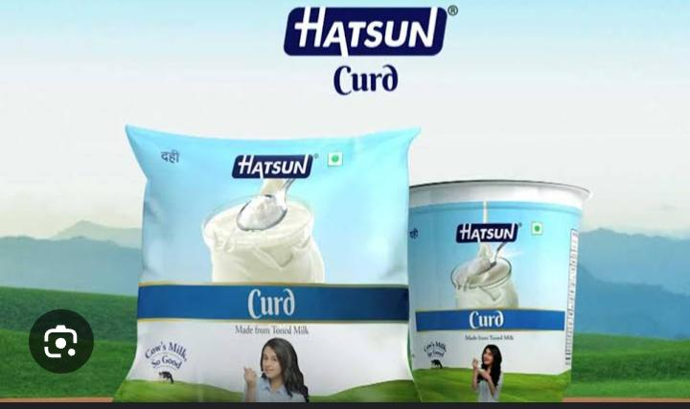1. \*Homepage\*: “Hatsun Agro Products Limited is a leading dairy products manufacturer in India, offering a range of dairy products including milk, curd, cheese, butter, and ghee.”

2. \*About Us\*: “Learn about Hatsun Agro Products Limited’s story, mission, and values. Discover how we’re committed to providing high-quality dairy products to our customers.”

3. \*Products\*: “Explore our range of dairy products, including milk, curd, cheese, butter, and ghee. Find out why we’re the preferred choice for dairy products in India.”

4. \*Contact Us\*: “Get in touch with Hatsun Agro Products Limited. Contact us for inquiries, feedback, or to learn more about our dairy products.”

Header Tags

1. \*H1 Tags\*: Use H1 tags for main headings, such as “Welcome to Hatsun Agro Products Limited” or “Our Dairy Products”.

2. \*H2 Tags\*: Use H2 tags for subheadings, such as “Our Story” or “Our Mission”.

3. \*H3 Tags\*: Use H3 tags for smaller subheadings, such as “Our Values” or “Our Products”.

Content Optimization

1. \*Keyword Research\*: Conduct keyword research to identify relevant keywords and phrases, such as “dairy products”, “milk”, “curd”, “cheese”, etc.

2. \*Content Creation\*: Create high-quality, engaging content that incorporates the identified keywords and phrases.

3. \*Content Length\*: Ensure that content is at least 500 words per page.

4. \*Content Format\*: Use a variety of content formats, such as text, images, videos, and infographics.

Image Optimization

1. \*Image File Names\*: Use descriptive file names that include target keywords, such as “hatsun-agro-products-milk.jpg”.

2. \*Image Alt Tags\*: Use descriptive alt tags that include target keywords, such as “Hatsun Agro Products milk”.

3. \*Image Captions\*: Use descriptive captions that include target keywords, such as “Hatsun Agro Products milk is fresh and pure”.

4. \*Image Compression\*: Compress images to reduce file size and improve page load times.

Internal Linking

1. \*Link to Relevant Pages\*: Link to relevant pages on the website, such as linking from the homepage to the products page.

2. \*Use Descriptive Anchor Text\*: Use descriptive anchor text that includes target keywords, such as “Learn more about our dairy products”.

3. \*Limit Number of Links\*: Limit the number of links on each page to improve user experience and reduce bounce rates.

Mobile-Friendliness

1. \*Responsive Design\*: Ensure that the website has a responsive design that adapts to different screen sizes and devices.

2. \*Mobile-Friendly Content\*: Ensure that content is mobile-friendly and easy to read on smaller screens.

3. \*Mobile-Friendly Navigation\*: Ensure that navigation is mobile-friendly and easy to use on smaller screens.

Page Speed

1. \*Optimize Images\*: Optimize images to reduce file size and improve page load times.

2. \*Minify CSS and JavaScript\*: Minify CSS and JavaScript files to reduce file size and improve page load times.

3. \*Leverage Browser Caching\*: Leverage browser caching to reduce the number of requests made to the server and improve page load times.

4. \*Use a Content Delivery Network (CDN)\*: Use a CDN to distribute content across different geographic locations and improve page load times.

Content ideas marketing strategies

Content Ideas

1. \*Blog Posts\*:

- “The Benefits of Consuming Fresh Milk”

- “The Importance of Dairy Products in a Balanced Diet”

- “The Story Behind Hatsun Agro Products Limited”

2. \*Social Media Posts\*:

- “Milk of the Month” feature, highlighting a different type of milk each month

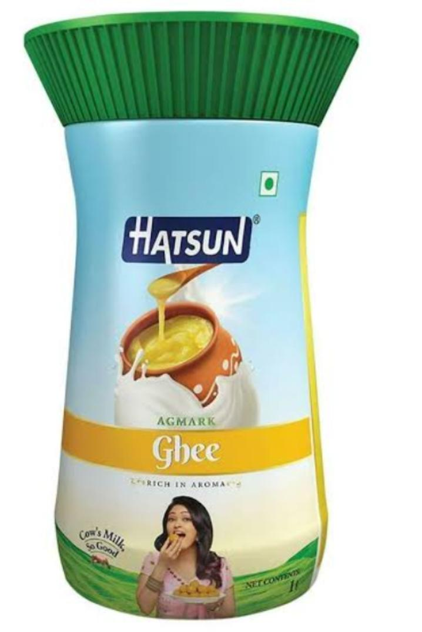 - “Dairy Recipe of the Week” feature, sharing a new recipe using Hatsun Agro Products Limited’s dairy products

- “Behind-the-Scenes” feature, giving followers a glimpse into the company’s operations

3. \*Videos\*:

- “The Journey of Milk from Farm to Table”

- “The Benefits of Grass-Fed Milk”

- “A Day in the Life of a Hatsun Agro Products Limited Farmer”

4. \*Infographics\*:

- “The Nutritional Benefits of Dairy Products”

- “The Process of Milk Production”

- “The Importance of Sustainable Dairy Farming”

5. \*Case Studies\*:

- “How Hatsun Agro Products Limited’s Dairy Products Helped a Local Business”

- “The Impact of Hatsun Agro Products Limited’s Sustainable Farming Practices”

Marketing Strategies

1. \*Influencer Marketing\*: Partner with social media influencers in the food and beverage industry to promote Hatsun Agro Products Limited’s dairy products.

2. \*Email Marketing\*: Create a monthly newsletter to share recipes, promotions, and company news with subscribers.

3. \*Social Media Advertising\*: Run targeted ads on Facebook, Instagram, and LinkedIn to reach new customers and increase brand awareness.

4. \*Content Marketing\*: Create high-quality, informative content to establish Hatsun Agro Products Limited as a thought leader in the dairy industry.

5. \*Event Marketing\*: Host events such as cooking demonstrations, farm tours, and workshops to educate customers about the benefits of Hatsun Agro Products Limited’s dairy products.

6. \*Referral Marketing\*: Implement a referral program to incentivize customers to refer friends and family to Hatsun Agro Products Limited’s dairy products.

7. \*Partnership Marketing\*: Partner with local businesses, restaurants, and cafes to offer Hatsun Agro Products Limited’s dairy products and increase brand visibility.

8. \*Search Engine Optimization (SEO)\*: Optimize Hatsun Agro Products Limited’s website and online content to improve search engine rankings and drive organic traffic.

Campaign Ideas

1. \*”Fresh from the Farm” Campaign\*: Highlight the freshness and quality of Hatsun Agro Products Limited’s dairy products by showcasing the company’s farming practices and milk production process.

2. \*”Dairy for All” Campaign\*: Emphasize the importance of dairy products in a balanced diet and promote Hatsun Agro Products Limited’s dairy products as a convenient and affordable option for all.

3. \*”Sustainable Dairy Farming” Campaign\*: Focus on Hatsun Agro Products Limited’s commitment to sustainable dairy farming practices and highlight the benefits of these practices for the environment and local communities.

Digital Marketing Channels

1. \*Website\*: (link unavailable)

2. \*Facebook\*: @hatsunagro

3. \*Instagram\*: @hatsunagro

4. \*Twitter\*: @hatsunagro

5. \*LinkedIn\*: @hatsunagro

6. \*YouTube\*: Hatsun Agro Products Limited

7. \*Email Newsletter\*: (link unavailable)

Budget Allocation

1. \*Content Creation\*: 30%

2. \*Social Media Advertising\*: 20%

3. \*Influencer Marketing\*: 15%

4. \*Email Marketing\*: 10%

5. \*Event Marketing\*: 5%

6. \*Referral Marketing\*: 5%

7. \*Partnership Marketing\*: 5%

Marketing strategies

Segmentation, Targeting, and Positioning (STP) Strategy

1. \*Segmentation\*: Target health-conscious individuals and families, as well as businesses in the food and beverage industry.

2. \*Targeting\*: Focus on urban and semi-urban areas, where there is a higher demand for high-quality dairy products.

3. \*Positioning\*: Position Hatsun Agro Products Limited as a premium dairy brand that offers high-quality, fresh, and nutritious dairy products.

Branding Strategy

1. \*Brand Identity\*: Develop a strong brand identity that reflects the company’s values and mission.

2. \*Logo\*: Use a logo that is simple, yet distinctive and memorable.

3. \*Tagline\*: Use a tagline that communicates the company’s unique selling proposition (USP), such as “Fresh from the Farm”.

4. \*Brand Messaging\*: Develop a consistent brand messaging framework that communicates the company’s value proposition and unique selling points.

Digital Marketing Strategy

1. \*Website\*: Develop a user-friendly website that provides detailed information about the company’s products and services.

2. \*Social Media\*: Use social media platforms such as Facebook, Instagram, and Twitter to engage with customers, promote products, and share company news.

3. \*Email Marketing\*: Use email marketing to send regular newsletters and promotional offers to customers.

4. \*Search Engine Optimization (SEO)\*: Optimize the website for search engines to improve visibility and drive organic traffic.

Content Marketing Strategy

1. \*Blog\*: Develop a blog that provides informative and engaging content about dairy products, health, and wellness.

2. \*Videos\*: Create videos that showcase the company’s products, services, and manufacturing process.

3. \*Infographics\*: Create infographics that provide information about dairy products, health, and wellness.

4. \*Case Studies\*: Develop case studies that showcase the company’s success stories and testimonials from satisfied customers.

Event Marketing Strategy

1. \*Trade Shows\*: Participate in trade shows and exhibitions to showcase the company’s products and services.

2. \*Product Launches\*: Host product launches and promotional events to introduce new products and services.

3. \*Farm Tours\*: Host farm tours and educational events to showcase the company’s farming practices and manufacturing process.

4. \*Workshops\*: Host workshops and training sessions to educate customers about dairy products, health, and wellness.

Public Relations (PR) Strategy

1. \*Media Outreach\*: Reach out to media outlets and publications to share company news and stories.

2. \*Press Releases\*: Distribute press releases to announce new products, services, and company news.

3. \*Crisis Communications\*: Develop a crisis communications plan to manage any negative publicity or crises.

4. \*Influencer Partnerships\*: Partner with influencers and thought leaders in the dairy industry to promote the company’s products and services.

Sales Promotion Strategy

1. \*Discounts\*: Offer discounts and promotions to customers to drive sales and increase revenue.

2. \*Loyalty Programs\*: Develop loyalty programs to reward repeat customers and encourage customer loyalty.

3. \*Free Samples\*: Offer free samples of new products to encourage customers to try them.

4. \*Trade Promotions\*: Offer trade promotions and discounts to businesses and retailers to drive sales and increase revenue.

Direct Marketing Strategy

1. \*Direct Mail\*: Use direct mail to send targeted promotional offers and messages to customers.

2. \*Telemarketing\*: Use telemarketing to follow up with customers and promote new products and services.

3. \*Email Marketing\*: Use email marketing to send targeted promotional offers and messages to customers.

4. \*SMS Marketing\*: Use SMS marketing to send targeted promotional offers and messages to customers.

Content creation and curation

Content Creation

\*Blog Posts\*

1. \*”The Benefits of Consuming Fresh Milk”\*: Highlight the nutritional benefits of fresh milk and how Hatsun Agro Products Limited’s milk is sourced from local farmers.

2. \*”The Importance of Dairy Products in a Balanced Diet”\*: Discuss the role of dairy products in a healthy diet and showcase Hatsun Agro Products Limited’s range of dairy products.

3. \*”Sustainable Dairy Farming Practices”\*: Share Hatsun Agro Products Limited’s commitment to sustainable dairy farming practices and their impact on the environment.

4. \*”Recipe of the Month”\*: Share a new recipe each month that incorporates Hatsun Agro Products Limited’s dairy products.

5. \*”Meet Our Farmers”\*: Profile one of Hatsun Agro Products Limited’s local farmers and share their story.

\*Social Media Posts\*

1. \*”Milk of the Month”\*: Highlight a different type of milk each month and share its benefits.

2. \*”Dairy Product of the Week”\*: Showcase a different dairy product each week and share its features and benefits.

3. \*”Behind-the-Scenes”\*: Share photos and videos of Hatsun Agro Products Limited’s manufacturing process and farm operations.

4. \*”Customer Testimonials”\*: Share testimonials from satisfied customers and showcase how Hatsun Agro Products Limited’s dairy products have made a difference in their lives.

5. \*”Infographics”\*: Create and share infographics that highlight the nutritional benefits of dairy products and Hatsun Agro Products Limited’s commitment to sustainability.

\*Videos\*

1. \*”The Story of Hatsun Agro Products Limited”\*: Create a corporate video that showcases Hatsun Agro Products Limited’s history, mission, and values.

2. \*”Sustainable Dairy Farming Practices”\*: Create a video that showcases Hatsun Agro Products Limited’s commitment to sustainable dairy farming practices.

3. \*”Meet Our Farmers”\*: Create a video that profiles one of Hatsun Agro Products Limited’s local farmers and shares their story.

4. \*”Recipe Videos”\*: Create recipe videos that showcase Hatsun Agro Products Limited’s dairy products and provide cooking tips and ideas.

Content Curation

\*Sources\*

1. \*Dairy industry reports and studies\*: Share relevant reports and studies from reputable sources such as the National Dairy Development Board and the Indian Dairy Association.

2. \*Health and wellness articles\*: Share articles from reputable sources such as Healthline and Harvard Health Publishing that highlight the nutritional benefits of dairy products.

3. \*Sustainability and environmental articles\*: Share articles from reputable sources such as The Guardian and Environmental Defense Fund that highlight the importance of sustainable dairy farming practices.

4. \*Customer-generated content\*: Encourage customers to share their experiences and recipes using Hatsun Agro Products Limited’s dairy products.

\*Channels\*

1. \*Social media\*: Share curated content on social media platforms such as Facebook, Twitter, and LinkedIn.

2. \*Blog\*: Share curated content on the Hatsun Agro Products Limited blog.

3. \*Newsletter\*: Share curated content in the Hatsun Agro Products Limited newsletter.

4. \*Email\*: Share curated content via email with subscribers.

Content Calendar

\*Monthly Themes\*

1. \*January\*: New Year, New You – Highlight the health benefits of dairy products and share recipes for healthy living.

2. \*February\*: Sustainability Month – Highlight Hatsun Agro Products Limited’s commitment to sustainable dairy farming practices and share tips on reducing waste and conserving resources.

3. \*March\*: Nutrition Month – Highlight the nutritional benefits of dairy products and share recipes that incorporate Hatsun Agro Products Limited’s dairy products.

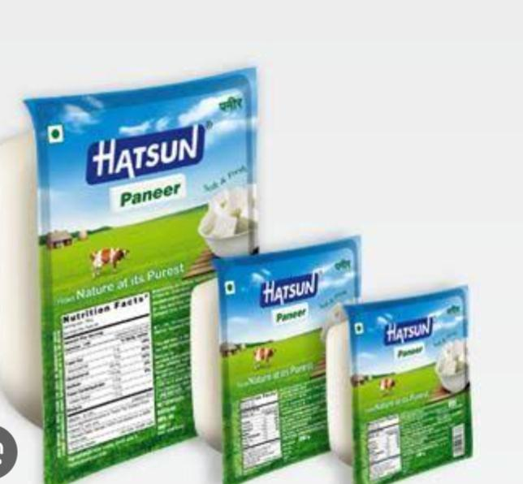

\*Weekly Posts\*

1. \*Monday\*: Motivation Monday – Share motivational quotes and stories related to health, wellness, and sustainability.

2. \*Tuesday\*: Tip Tuesday – Share tips and advice related to dairy products, health, and wellness.

3. \*Wednesday\*: Wellness Wednesday – Share articles and stories related to health and wellness.

4. \*Thursday\*: Throwback Thursday – Share vintage photos and stories related to Hatsun Agro Products Limited’s history.

5. \*Friday\*: Feature Friday – Highlight a different dairy product or recipe each week.

Content Metrics

\*Key Performance Indicators (KPIs)\*

1. \*Website traffic\*: Monitor website traffic and engagement metrics such as page views, unique visitors, and bounce rate.

2. \*Social media engagement\*: Monitor social media engagement metrics such as likes, shares, comments, and followers.

3. \*Email open rates\*: Monitor email open rates and click-through rates.

4. \*Conversion rates\*: Monitor conversion rates such as sales, leads, and downloads.

Content Team

\*Roles and Responsibilities\*

1. \*Content Manager\*: Responsible for developing and implementing the content strategy, creating and curating content, and managing the content calendar.

2. \*Social Media Manager\*: Responsible for managing social media accounts, creating and scheduling social media

